**AN INTRODUCTION TO HOSPITAL DATABASE**

Hospitals are the most important part of our lives, trying to provide the best medical facilities to people suffering from various type of illness, which may be due to change in climate conditions, increased work-load, emotional trauma stress etc. It is very much difficult for the hospital to maintain its day-to-day activities and records manually. That is why a database is required to keep records of all type of activities of a hospital.

***List of tables in the hospital database:***

* physician
* department
* affiliated_with
* procedure
* trained_in
* patient
* nurse
* appointment
* medication
* prescribes
* block
* room
* on_call
* stay
* undergoes

**ER DIAGRAM:**

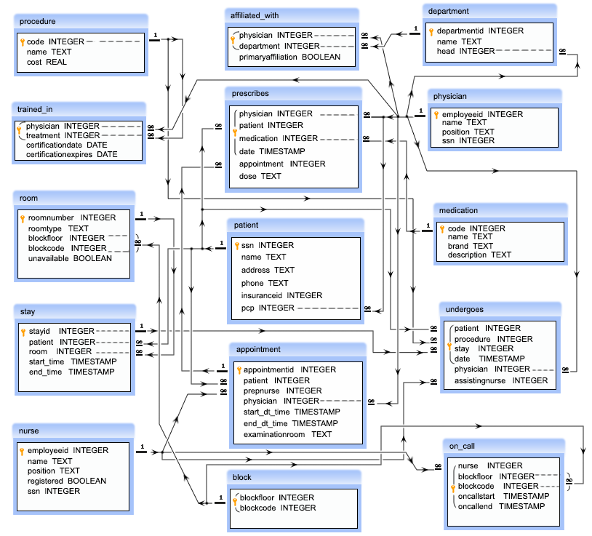

***Physician:***

* employeeid – this is a unique ID of a physician
* name – this is the name of a physician
* position – this is the designation of a physician
* ssn – this is a security number of a physician

***department:***

* departmentid – this is a unique ID for a department
* name – this is the name of a department
* head – this is the ID of the physician who is the head of a department, referencing to the column employeeid of the table physician

***affiliated_with:***

* physician – this is the ID of the physicians which is referencing to the column employeeid of the physician table
* department – this is the ID the department which is referencing to the column departmentid of the department table
* primaryaffiliation – this is a logical column which indicate that whether the physicians are yet to be affiliated or not
* *Note: The combination of physician, department will come once in that table.*

***procedure:***

* code – this is the unique ID of a medical procedure
* name – the name of the medical procedure
* cost – the cost for the procedure

***trained_in:***

* physician – this is ID of the physicians which is referencing to the column employeeid of the physician table
* treatment – this is the ID of the medical procedure which is referencing to the column code of the procedure table
* certificationdate – this is the starting date of certification
* certificationexpires – this is the expiry date of certification
* *Note: The combination of physician and treatement will come once in that table.*

***patient:***

* ssn – this is a unique ID for each patient
* name – this is the name of the patient
* address – this is the address of the patient
* phone – this is the phone number of the patient
* insuranceid – this is the insurance id of the patient
* pcp – this is the ID of the physician who primarily checked up the patient which is referencing to the column employeeid of the physician table

***nurse:***

* employeeid – this is the unique ID for a nurse
* name – name of the nurses
* position – the designation of the nurses
* registered – this is a logical column which indicate that whether the nurses are registered for nursing or not
* ssn – this is the security number of a nurse

***appointment:***

* appointmentid – this is the unique ID for an appointment
* patient – this is the ID of each patient which is referencing to the ssn column of patient table
* prepnurse – the ID of the nurse who may attend the patient with the physician, which is referencing to the column employeeid of the nurse table
* physician – this is the ID the physicians which is referencing to the employeeid column of the physician table
* start_dt_time – this is the schedule date and approximate time to meet the physician
* end_dt_time – this is the schedule date and approximate time to end the meeting
* examinationroom – this the room where to meet a patient to the physician

***medication:***

* code – this is the unique ID for a medicine
* name – this is the name of the medicine
* brand – this is the brand of the medicine
* description – this is the description of the medicine

***prescribes:***

* physician – this is the ID of the physician referencing to the employeeid column of the physician table
* patient – this is the ID of the patient which is referencing to the ssn column of the patient table
* medication – the ID of the medicine which is referencing to the code of the medication table
* date – the date and time of the prescribed medication
* appointment – the prescription made by the physician to a patient who may taken an appointment which is referencing to column appointmentid of appointment table
* dose – the dose prescribed by the physician
* *Note: The combination of physician, patient, medication, date will come once in that table.*

***block:***

* blockfloor – ID of the floor
* blockcode - ID of the block
* *Note: The combination of blockfloor, blockcode will come once in that table.*

***room:***

* roomnumber – this is the unique ID of a room
* roomtype – this is type of room
* blockfloor - this is the floor ID where the room in
* blockcode – this is the ID of the block where the room in
* unavailable – this is the logical column which indicate that whether the room is available or not
* *Note: The of blockfloor, blockcode columns are refercing to the combination of blockfloor and blockcode columns of the table block.*

***on_call:***

* nurse – this is ID of the nurse which is referencing to the employeeid column of the table nurse
* blockfloor - this is the ID of the floor
* blockcode – this is the ID of block
* oncallstart - the starting date and time of on call duration
* oncallend – the ending date and time of on call duration
* *Note: The combination of nurse, blockfloor, blockcode, oncallstart, oncallend will come once in that table and the combination of blockfloor, blockcode columns are refercing to the combination of blockfloor and blockcode columns of the table block .*

***stay:***

* stayid - this is unique ID for the admission
* patient – this is the ID of the patient which is referencing the ssn column of patient table
* room - this is the ID of the room where the patient admitted and which is referencing to the roomnumber column of the room table
* start_time – this is the time when a patient admitted
* end_time – this is the time how long a patient is staying

***undergoes:***

* patient - this is ID of the patient which is referencing to the ssn column of the patient table
* procedure – this is ID of the procedure and referencing to the code column of the procedure table
* stay - this is the ID admission of a patient, which is referencing to the stayid column of the stay table
* date – this is the date when a patient undergoes for a medical procedure
* physician – this is the ID of a physician which is referencing to the column employeeid of the table physician
* assistingnurse – this is the ID of a nurse who will assists the physician, referencing to the column employeeid of the table nurse
* *Note: The combination ofpatient, procedure, stay, date will come once in that table.*

Following are the Questions:-

1) Write a query in SQL to find all the information of the nurses who are yet to be registered.

2) Write a query in SQL to find the name of the nurse who are the head of their department.

3) Write a query in SQL to obtain the name of the physicians who are the head of each department.

4)Write a query in SQL to count the number of patients who taken appointment with at least one physician.

5)Write a query in SQL to find the floor and block where the room number 212 belongs to.

6)Write a query in SQL to count the number available rooms

7)Write a query in SQL to count the number of unavailable rooms.

8)Write a query in SQL to obtain the name of the physician and the departments they are affiliated with.

9)Write a query in SQL to obtain the name of the physicians who are trained for a special treatement.

10)Write a query in SQL to obtain the name of the physicians with department who are yet to be affiliated.

11)Write a query in SQL to obtain the name of the physicians who are not a specialized physician.

12)Write a query in SQL to obtain the name of the patients with their physicians by whom they got their preliminary treatement.

13)Write a query in SQL to find the name of the patients and the number of physicians they have taken appointment.

14)Write a query in SQL to count number of unique patients who got an appointment for examination room C.

15)Write a query in SQL to find the name of the patients and the number of the room where they have to go for their treatment.

16)Write a query in SQL to find the name of the nurses and the room scheduled, where they will assist the physicians.

17)Write a query in SQL to find the name of the patients who taken the appointment on the 25th of April at 10 am, and also display their physician, assisting nurses and room no.

18)Write a query in SQL to find the name of patients and their physicians who does not require any assistance of a nurse.

19)Write a query in SQL to find the name of the patients, their treating physicians and medication

20)Write a query in SQL to find the name of the patients who taken an advanced appointment, and also display their physicians and medication.

21)Write a query in SQL to find the name and medication for those patients who did not take any appointment.

22)Write a query in SQL to count the number of available rooms in each block.

23)Write a query in SQL to count the number of available rooms in each floor.

24)Write a query in SQL to count the number of available rooms for each block in each floor.

25)Write a query in SQL to count the number of unavailable rooms for each block in each floor.

26)Write a query in SQL to find out the floor where the maximum no of rooms are available.

27)Write a query in SQL to find out the floor where the minimum no of rooms are available

28)Write a query in SQL to obtain the name of the patients, their block, floor, and room number where they are admitted.

29)Write a query in SQL to obtain the nurses and the block where they are booked for attending the patients on call.

30)Write a query in SQL to make a report which will show -

a) name of the patient,

b) name of the physician who is treating him or her,

c) name of the nurse who is attending him or her,

d) which treatement is going on to the patient,

e) the date of release,

f) in which room the patient has admitted and which floor and block the room belongs to respectively.

31) Write a SQL query to obtain the names of all the physicians performed a medical procedure but they are not ceritifed to perform.

32)Write a query in SQL to obtain the names of all the physicians, their procedure, date when the procedure was carried out and name of the patient on which procedure have been carried out but those physicians are not cetified for that procedure.

33) Write a query in SQL to obtain the name and position of all physicians who completed a medical procedure with certification after the date of expiration of their certificate.

34) Write a query in SQL to obtain the name of all those physicians who completed a medical procedure with certification after the date of expiration of their certificate, their position, procedure they have done, date of procedure, name of the patient on which the procedure had been applied and the date when the certification expired.

35) Write a query in SQL to obtain the names of all the nurses who have ever been on call for room 122.

36) Write a query in SQL to Obtain the names of all patients who has been prescribed some medication by his/her physician who has carried out primary care and the name of that physician.

37) Write a query in SQL to obtain the names of all patients who has been undergone a procedure costing more than $5,000 and the name of that physician who has carried out primary care.

38)Write a query in SQL to Obtain the names of all patients who had at least two appointment where the nurse who prepped the appointment was a registered nurse and the physician who has carried out primary care.

39) Write a query in SQL to Obtain the names of all patients whose primary care is taken by a physician who is not the head of any department and name of that physician along with their primary care physician.